# **Business Question and Visualization Report**

|  |  |
| --- | --- |
| Date | 28-07-2025 |
| Team ID | SIMRAN GUPTA |
| Project Name | Predicting Plant Growth Stages with Environmental and Management Data Using Power BI |
| Maximum  Marks | 5 Marks |

Visualization development refers to the process of creating graphical representations of data to facilitate understanding, analysis, and decision-making. The goal is to transform complex datasets into visual formats that are easy to interpret, enabling users to gain insights and make informed decisions. Visualization development involves selecting appropriate visual elements, designing layouts, and using interactive features to enhance the user experience. This process is commonly associated with data visualization tools and platforms, and it plays a crucial role in business intelligence, analytics, and reporting

# Business Questions and Visualisation

The process involves defining specific business questions to guide the creation of meaningful and actionable visualizations in Power BI. Well-framed questions help in identifying key metrics, selecting relevant data, and building visualisation that provide insights. To create a comprehensive Business Question and Visualization Report, follow these steps:

**Q1. Which soil type supports the highest total plant growth?**

Clay soil supports the highest total growth with 67 units, followed by sandy (64 units) and loam (62 units), as per the decomposition tree analysis.

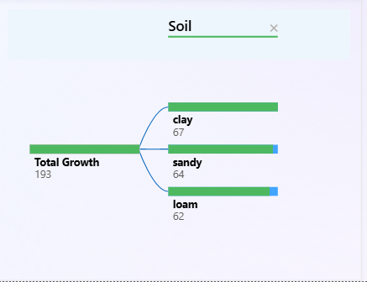

**Q2. What impact does temperature have on total plant growth?**

A decrease in temperature below 60.59°C (sum) causes the average Total_Growth to decrease by 1.76 units, as shown by the Key Influencers visual.

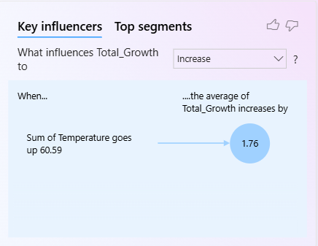

**Q3. Which watering frequency proves most beneficial for plant growth?**

Daily watering frequency shows better and more consistent growth results, especially when combined with clay soil.

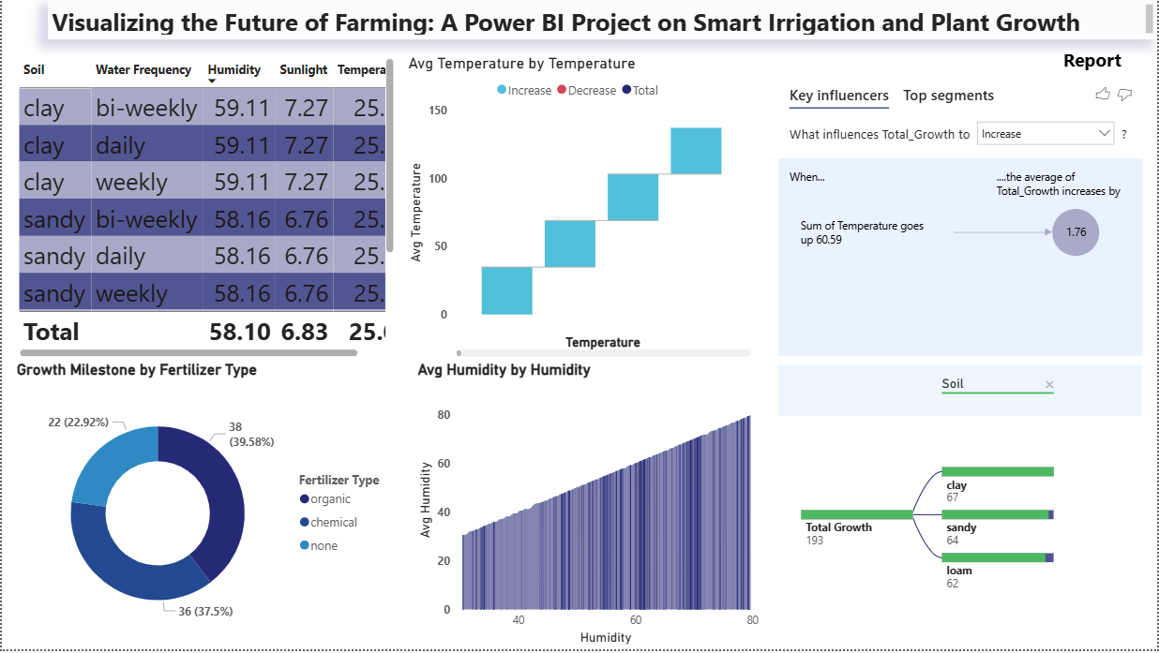

**Q4. Which fertilizer type contributes most to plant growth milestones?**

Organic fertilizers account for the highest contribution (39.58%) to growth milestones, followed closely by chemical fertilizers (37.5%).



**Q5. How does humidity affect overall plant growth?**

Higher humidity levels correlate with better growth results, especially in clay soil conditions. Average humidity in optimal growth cases was around 59.11%.

**Q6. What combination of conditions leads to optimal plant growth?**

 The best results were observed in clay soil, with daily watering, high humidity (around 59%), and moderate temperature (around 34°C), when organic fertilizers were used.

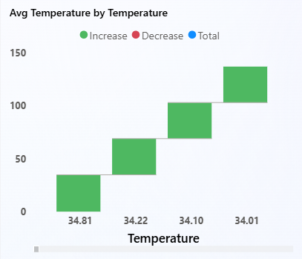

**Q7. How can this dashboard benefit agricultural decision-makers?**

It provides interactive visual insights on how different environmental and input factors impact growth, enabling data-driven decisions for crop planning and irrigation policy.

**Q8. What are the key insights for future smart irrigation systems?**

Future systems should:

* Prioritize clay-based fields
* Automate watering frequency based on temperature and humidity
* Promote use of organic fertilizers
* Use real-time environmental monitoring to adjust irrigation dynamically